

MES Traceability Solution

Microtek International Pvt. Ltd.

Software Requirement Specification (SRS)
Project ID:
BAR CODE INDIA, 145 Udyog Vihar Phase 1, Gurugram, Haryana-122016, PH: 0124 4337555

Prepared By: Leena
Submission Date: 04.07.2022
Version: 1.0
The document details the summary of solution architecture and approach for the development of MES Traceability Solution for Microtek International Pvt. Ltd. The document is based on the inputs, system study, discussions and meeting held between BCI & Microtek International Pvt. Ltd Teams.

Vendor Portal

Label Printing
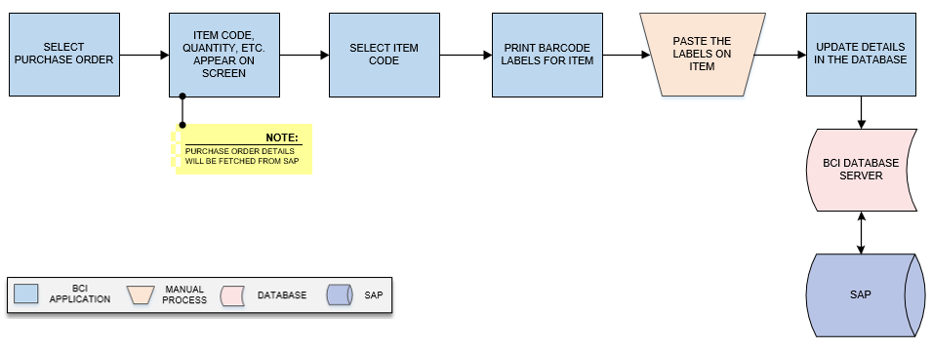
Activities
Module Description | This module will provide unique identification to each Item using Barcode labels against Production Order & Item code. The printing details will be updated in the database.

Pre-Conditions | - Vendor master should be available.  - Vendor details should be saved in Vendor master.  - Interface will be required to fetch Purchase Order details from SAP.

Process Steps | - Select Purchase Order.  - Corresponding details such as Item Code, Quantity etc. appear on screen.  *Purchase Order details will be fetched from SAP.  - Select Item Code.  - Print barcode labels for Item.  - Paste the labels on Item.  - Update corresponding details in database.

Post-Conditions | - Printing details will get saved in the database.

Validations | - An alert should be displayed in case duplicate/ invalid barcode is scanned.  - An alert should be displayed in case Item Code are not available in list.  - An alert should be displayed invalid Item Code is selected.  - An alert should be displayed in case Purchase order details are not fetched from SAP.

Secondary Packing
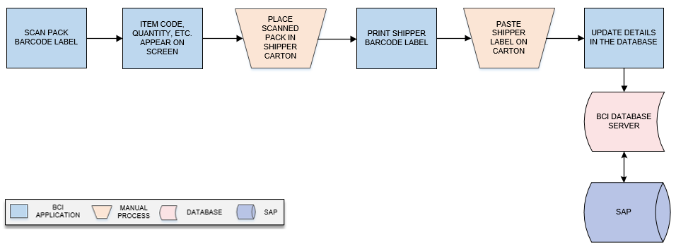
Activities
Module Description | In this module primary packs are packed in Shipper Carton as per pack size and system will print Shipper label; corresponding packing details will be updated in the database.

Pre-Conditions | - Barcode Labels should be printed for Primary packs.

Process Steps | - Scan Pack Barcode Label.  - Corresponding details such as Item Code, Quantity (Suggest if any) etc. appear on screen.  - Place scanned Pack in Shipper Carton as per pack size.  - Print Shipper Barcode Label.  - Paste Shipper label on Carton.  - Save packing details in the database.

Post-Conditions | - Shipper Barcode printing details will get saved in the database.  - Carton which are packed will move for Dispatch.

Validations | - An alert should be displayed in case duplicate/ invalid barcode is scanned.  - An alert should be displayed in case Item Code are not available in list.  - An alert should be displayed invalid Item Code is selected.

Dispatch
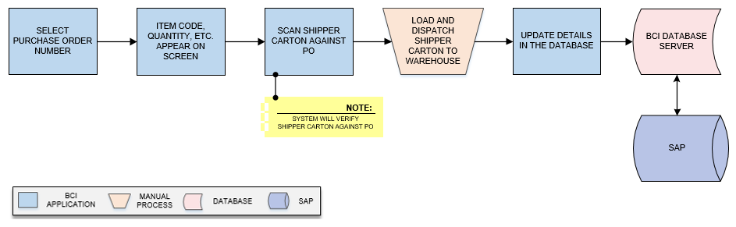
Activities
Module Description | This module will help user to dispatch Shipper Carton from Vendor against received Purchase Order and to update the dispatch details in database.

Pre-Conditions | - Purchase Order should be available.

Process Steps | - Select Purchase Order Number.  - Corresponding details such as Item Code, Quantity (Suggest if any) etc. appear on screen.  - Scan Shipper Carton against PO.  *System will verify Shipper Carton against PO.  - Repeat steps from 1 to 3 until all cartons against Purchase Order are scanned.  - Load and dispatch Shipper Carton to warehouse.  - Update corresponding dispatch details in database.

Post-Conditions | - Transaction details are saved in database.

Validations | - An alert should be displayed in case duplicate/ invalid Carton is scanned.  - Alert should be displayed if Purchase Order Number is not available in list.

FG Warehouse Operation

Receiving
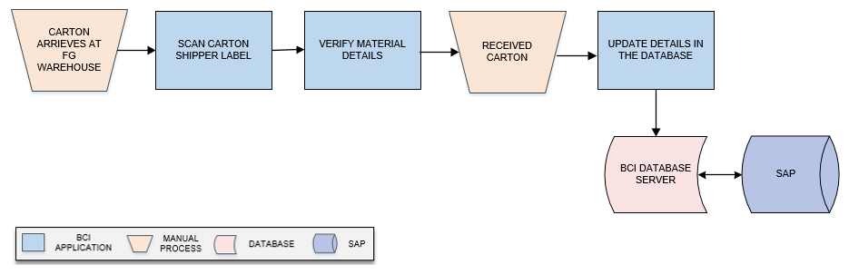
Activities
Module Description | This module will let user to scan & receive Carton from Shop Floor and the inventory details will be updated in the database.  *This activity will be done using Device Application.

Pre-Conditions | - FG cartons shall be received at FG warehouse.  - Carton Shipper label should be present.

Process Steps | - Cartons will arrive at FG Warehouse.  - Scan Carton Shipper Label.  - Verify material details.  - Receive Cartons.  - Save details in the database.

Post-Conditions | - Inventory details will get updated in database.

Validations | - An alert should be displayed in case duplicate/ invalid barcode label is scanned.  - An alert should be displayed in case of invalid activity.

Putaway
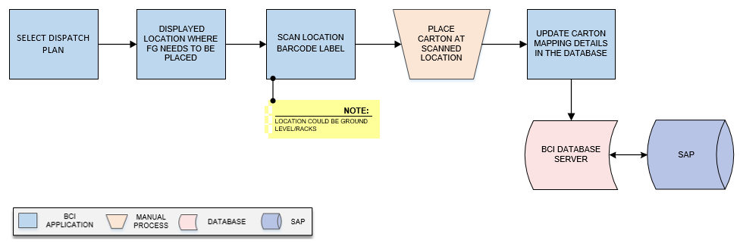
Activities
Module Description | The module will be used to place the FG Cartons on storage location suggested by System and to update the Location-Carton mapping details in database.  *This activity will be done using Device Application.

Pre-Conditions | - Location Label should be printed using the Location Identification module  - Location Code and Location Type should be defined.  - Cartons should have barcode labels.  - HHT device should be available.

Process Steps | - Scan FG Carton barcode label.  - System will display location where FG carton needs to be placed.  - Scan Location Barcode label.  *Location could be Ground level/ Racks.  - Place the Carton at scanned Location  - Location – Carton mapping details will be updated in the database.

Post-Conditions | - Location-Carton mapping will be stored in database.

Validations | - An alert should be displayed in case user scan other location than defined or suggested Location.  - An alert should be displayed in case duplicate / invalid barcode label is scanned.  - Location-Item category mapping data should be updated in database.

Picklist Generation
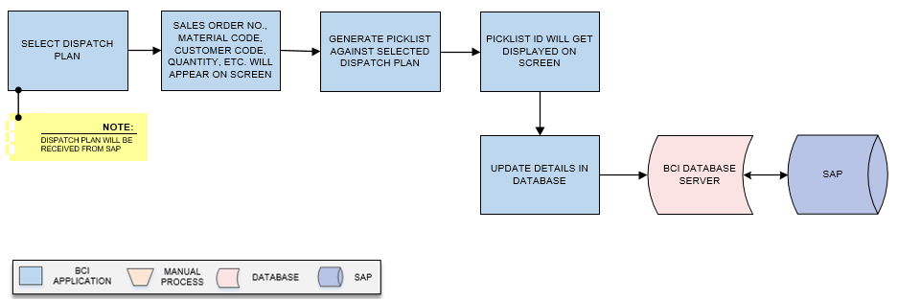
Activities
Module Description | In this module, the Picklist will be generated against Dispatch Plan and a unique Picklist ID will be returned. The Dispatch Plan will be fetched from SAP.  *This activity will be done using Device Application.

Pre-Conditions | - Dispatch plan should be fetched from SAP.  - Interface will be required to fetch Dispatch Plan from SAP.

Process Steps | - Select Dispatch Plan.  *Dispatch Plan will be received from SAP.  - Sales Order No., Material Code, Customer Code, Quantity, etc. will appear on screen.  - Generate Picklist against selected Dispatch Plan.  - Picklist ID will get displayed on screen.  - Update details in database.

Post-Conditions | - Picklist ID is generated by system.  - User should be able to view the Picklist while Picking

Validations | - An alert should be displayed in case Stock quantity is not available.  - An alert should be displayed in case of invalid activity.  - System will not allow user to enter more quantity than Stock available quantity.  - System shall generate unique Picklist ID.
Data Required from Microtek | - Interface will be required to fetch/ pull Dispatch Plan details from SAP and same will be provided by Microtek.

FG Picking
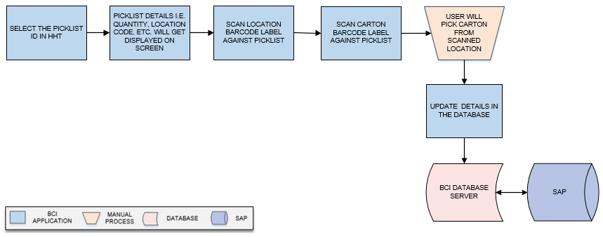
Activities
Module Description | This module will allow user to scan and pick the FG material carton against Picklist from the location suggested by system. System will verify the Carton against Picklist and details for the same will be updated in database.  *This activity will be done using Device Application.

Pre-Conditions | - Picklist should be created  - Carton should have barcode label.  - Picklist ID should be available in list.  - HHT device should be available.

Process Steps | - Select the Picklist ID in HHT.  - Picklist details i.e. Quantity, Location Code, etc. will get displayed on screen.  - Scan Location Barcode Label against Picklist.  - Scan Carton Barcode Label against Picklist.  - User will pick Carton from scanned Location.  - Details are saved in the database.

Post-Conditions | - Carton which are picked will move for Dispatch.  - Inventory should get updated as per picking.

Validations | - An alert should be displayed in case duplicate/ invalid barcode is scanned.  - An alert should be displayed if Picklist is not available in list.  - An alert should be displayed if wrong Carton is picked.  - An alert will be displayed if Picked quantity entered is more than the quantity stated in Picklist.

FG Dispatch
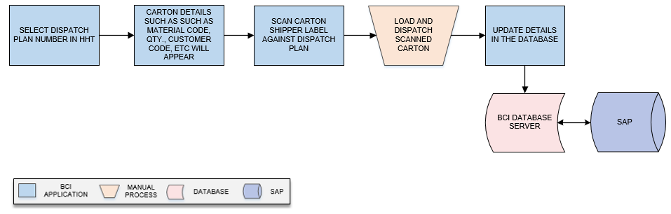
Activities
Module Description | In this process, Carton will be scanned and dispatched against Dispatch Plan and details for the same will get updated in database.  *This activity will be done using Device Application.

Pre-Conditions | - Dispatch Plan should be available  - Interface will be required to fetch Dispatch Plan from SAP.  - Picking should be complete.

Process Steps | - Select Dispatch Plan Number in HHT.  - Carton details such as Such as Material Code, Qty., Customer Code, etc will appear.  - Scan Carton Shipper Label against Dispatch plan.  - Repeat steps from 1 to 3 until all cartons against Dispatch Plan are scanned.  - Load and dispatch scanned Carton.  - Update dispatch details in the database.

Post-Conditions | - Transaction details are saved in database.

Validations | - An alert should be displayed in case duplicate/ invalid carton is scanned.  - Alert should be displayed if Dispatch Plan is not available in list.
Label Design | Sample Barcode label design for FG operation is given below:  